Science Masterpiece
3rd Grade – 3rd Quarter
Experiment 8: Solids and Liquids
What Does Salt Do to Ice?
Thank you for volunteering to teach the students a Science Masterpiece Lesson!
Please coordinate with your teacher on a day and time, it is flexible and should be convenient for both of you. The lesson should take about 1 hour of your time in the kid’s classroom.
Review the laminated Experiment Guide. Not all parts of the Guide are utilized.
Review the PowerPoint presentation provided. There is a YouTube video embedded into the presentation. Please be mindful of any ads that may pop up, unfortunately we cannot control that. To make the video play, please remind the teachers to download the video in PowerPoint and click “Enable Editing” and then “Enable Content”.
Please email the teacher with your final PowerPoint before your scheduled time.
Everything you need for Science Masterpiece are in specific labeled plastic tubs. The tubs can be found in the work room (front desk can direct you), on the top shelf, labeled by grade.
After you have finished teaching the Science Masterpiece Lesson, please ensure to pack everything back into the tub so the next class can use it.
Important Notes:
In your tub there are 30 plastic containers, break up kids into groups of 2 (2 containers per group).
You will need to bring a bag of ice. The Lesson Plans says you’ll need 6 ice cubes per container, we suggest using more.
- Fill the containers with the water and ice.
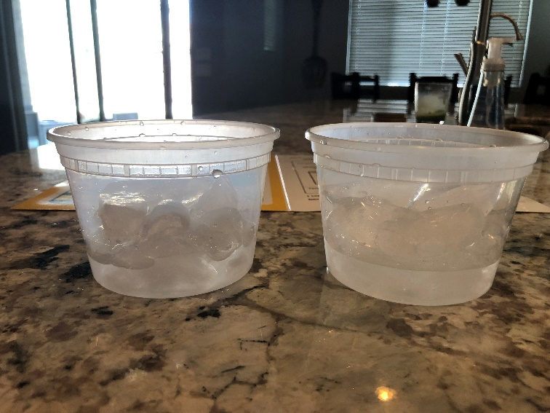
Water line
- Insert the thermometer and take the temperature after 1 min, they should be the same temperature.
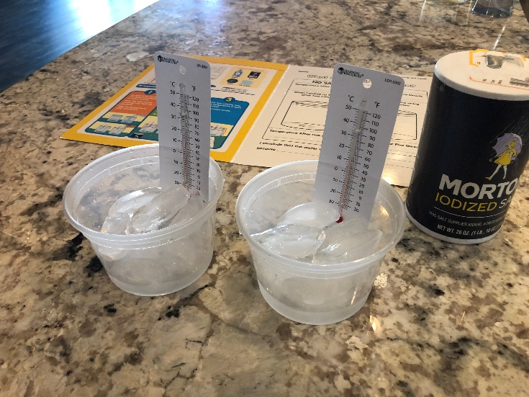
- Cut a piece of yarn long enough to stretch across the 2 containers. Make sure you dip the sting in the water, the string has to be wet for the desired results.
- Pour the salt over the ice of one container. Don’t worry about measuring the salt, just generously cover the ice.
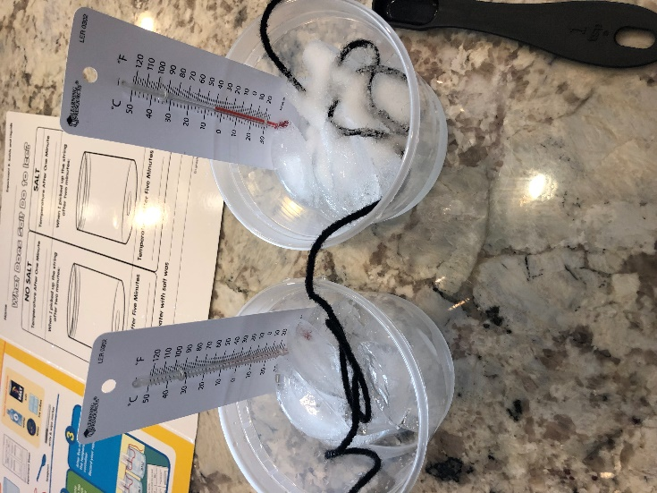

- After two additional minutes, pick up both strings and see the difference.
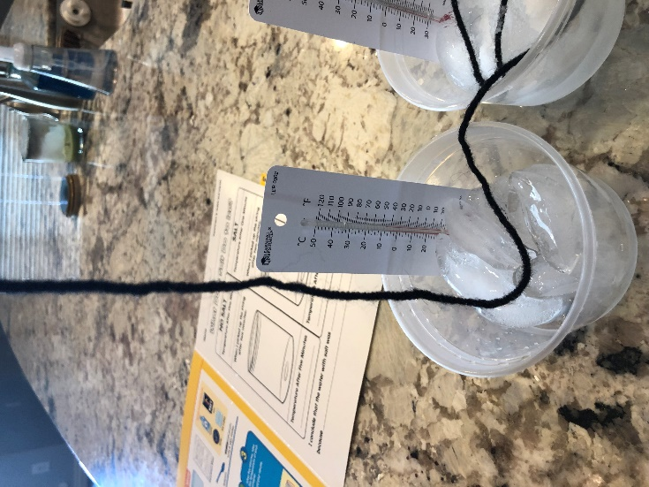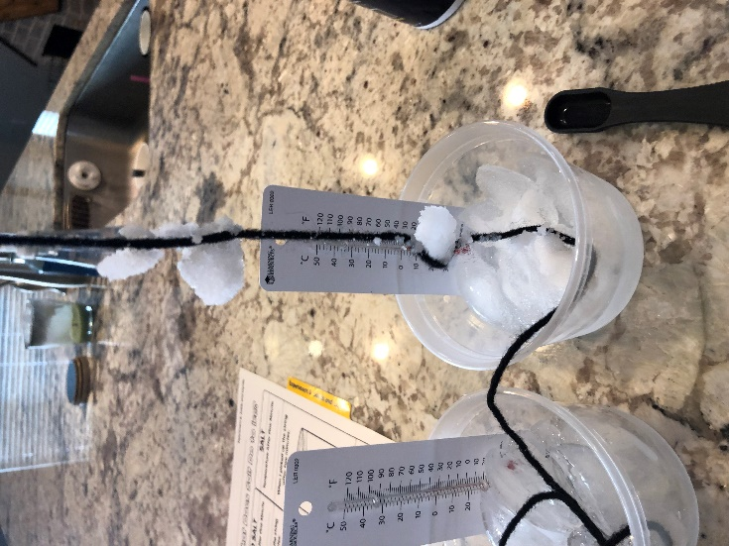
Ice will stick to the yarn in the container with salt.
No ice should stick to the yarn in the container without salt.
- Take the temperature of the containers again after an additional five minutes, the salt container should be colder.
The print outs for each of the students to record their findings are provided in the tub.
If you have any questions, please contact the Science Masterpiece Team at DMEscience@gmail.com.
If you are unable to make your schedule time, please let us know.
Thank You and Have Fun!
Science Masterpiece Team!

