Science Masterpiece
4th Grade – 2nd Quarter
Experiment: Scientific Method
What is the Scientific Method?
Thank you for volunteering to teach the students a Science Masterpiece Lesson!
Please coordinate with your teacher on a day and time, it is flexible and should be convenient for both of you. The lesson should take about 1 hour of your time in the kid’s classroom.
This experiment does not have a PowerPoint presentation; instead, this experiment utilizes a tri-fold board. The board will be stored above the Science Masterpiece bins in the workroom. You will teach about the Scientific Method by performing an experiment using M&M’s. The materials are in the bin labeled 4th Grade in the workroom
After you have finished teaching the Science Masterpiece Lesson, please ensure to pack everything back into the tub so the next class can use it.
Important Notes:
In your bin there are 15 plastic containers, break up kids into groups of 2.
Use 1 snack size package of M&M’s per container. Use water from the sink in the classroom to fill the large measuring cup.
Please review the following pages for notes on how to walk through the Scientific Method.
If you have any questions, please contact the Science Masterpiece Team at DMEscience@gmail.com.
If you are unable to make your scheduled time, please let us know.
Thank You and Have Fun!
Science Masterpiece Team!
Jen Silverman and Valerie Shinpaugh

Scientific Method

What is the Scientific Method?
The Scientific Method is a methodical process used to answer a question. Scientists gather and look at evidence to come up with an answer to a question.

The Steps
- Ask a Question.
  - About something you observe.

- Form a Hypothesis.
  - A Hypothesis is an educated guess.

- Procedure
  - Write the steps you will take to test your hypothesis.

- Experiment
  - Complete several trials to test your hypothesis.
  - Only test 1 variable at a time.

- Data
  - Keep a record of what you find and do.

- Conclusion
  - Make a decision about your hypothesis based on the data you found. .

- There are many versions of the Scientific Method, but they all have the same goal, to find answers to a question. For example, if you are a paleontologist and you are studying dinosaurs, you will modify the Scientific Method, because you can not observe live dinosaurs.

- During an experiment there can be several variables. Variables are what you can change about the experiment, for example, the temperature of the water or the kind of liquid you use. It’s important to keep track of each experiment.

- It is also important to keep track of your steps and your data, because experiments need to be repeatable. The experiment should also be well documented so other Scientists can perform the same test.

Experiment Time
To help the kids understand the Scientific Method, you will be using the tri-fold board to walk through an experiment.
      - Pass out the cups as well as a package of M&M’s to each group.

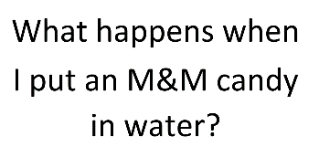
      - Start with “Ask A Question”. Place the laminated answer for that step on the board.

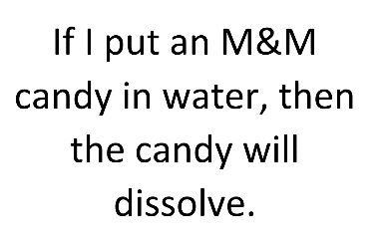
      - Do the same for “Hypothesis”.

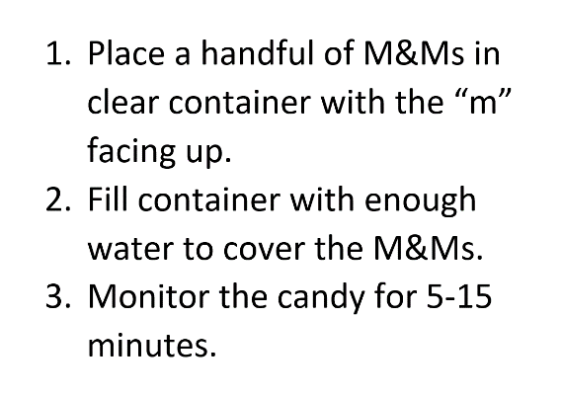
      - At step 3, “Procedure”, have the kids perform the experiment. Place the laminated answer on step 3. Use the large measuring cup to add water to the experiment cups. Make sure the “M’s” are facing up.

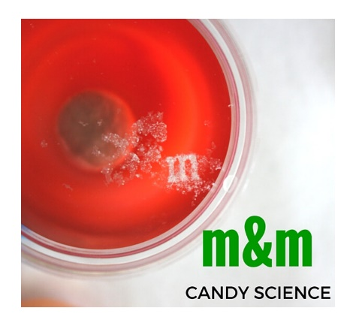
      - Place the laminated answer for “Experiment” while the kids are performing their experiment.

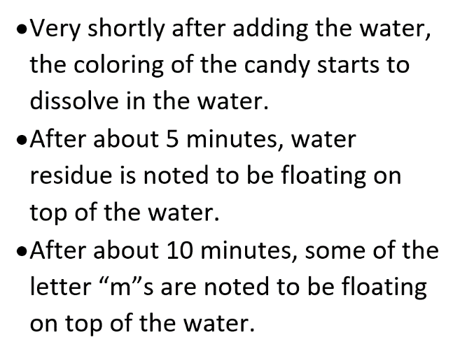
      - While you’re observing the candy for 5-15 mins, have the kids discuss the steps taken to collect the data. Place the laminated answer under “Data”. In an attempt to keep the variables the same, ensure the kids don’t move the cups around or try to stir the M&M’s.

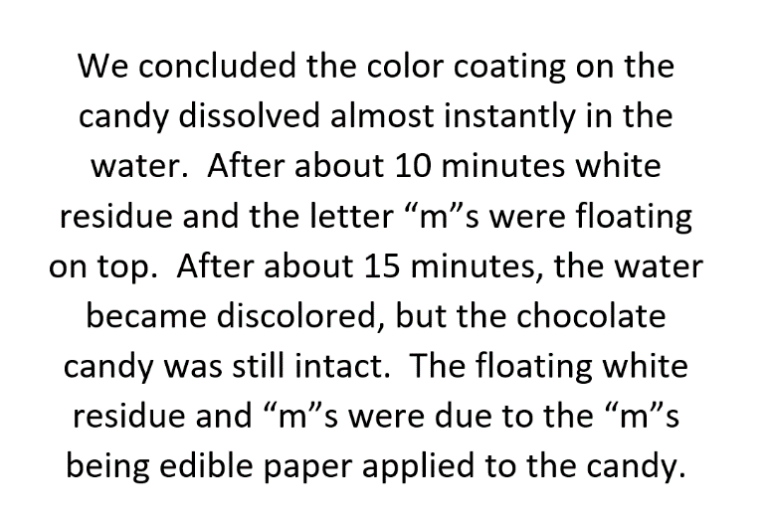
      - Once the “M’s” have floated to the top, discuss the conclusion and place the laminated answer on the board.

Conclusion

Discuss the results of the experiment verses the Hypothesis. Explain if the outcome of the experiment is different than the hypothesis, it is still a good experiment and new data can still be learned.

Questions
What variables could we have changed?
Were you surprised by the outcome?
Did you enjoy this experiment?
What other experiments could you do?

