Science Masterpiece
Kindergarten – 1st Quarter
Experiment 1: Sense of Touch
How Does It Feel?
Thank you for volunteering to teach the students a Science Masterpiece Lesson!
Please coordinate with your teacher on a day and time, it is flexible and should be convenient for both of you. The lesson should take about 1 hour of your time in the kid’s classroom.
Review the lesson plan and PowerPoint presentation provided. Please feel free to add/change the PowerPoint if you would like. There is a YouTube video embedded into the presentation. Please be mindful of any ads that may pop up, unfortunately we cannot control that.
Please email the teacher with your final PowerPoint before your scheduled time.
Everything you need for Science Masterpiece are in specific labeled plastic tubs. The tubs can be found in the work room (front desk can direct you), on the top shelf, labeled by grade.
After you have finished teaching the Science Masterpiece Lesson, please ensure to pack everything back into the tub so the next class can use it.
Important Notes:
In your tub there are 6 bags of items, break up kids into groups accordingly.
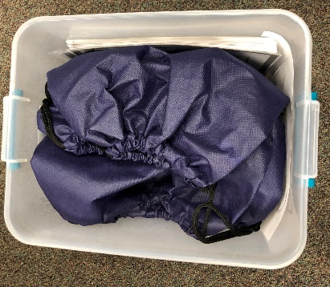

The worksheet portion of the lesson differs slightly. Instead of worksheet to draw the object and describe it, we have created a new worksheet, and the students will just need to guess the object, based on what they feel.
There are 6 laminated copies of the following sheet to be distributed to each group.
If you have any questions, please contact the Science Masterpiece Team at DMEscience@gmail.com.
If you are unable to make your schedule time, please let us know.
Thank You and Have Fun!
Science Masterpiece Team!

